Project Name : Location Search

Project Details :

It will be a website.User will search a location(address, for example, Dhanmondi 27) here and get five options.

1. Hospital
2. Shopping Complex
3. Hotel/Guest House
4. Restaurant
5. Tourist places

Then user will choose one of those 5 options.Imagine that user chose shopping complex .Then user will get a list of all shopping complex that are situated in that area(location).After getting list,user can click a single shopping complex and get some information (image, list of categories that are available there floor-wise,address detail) about that.

Let’s start the journey...

Step 1: Put a location (a short address is enough)

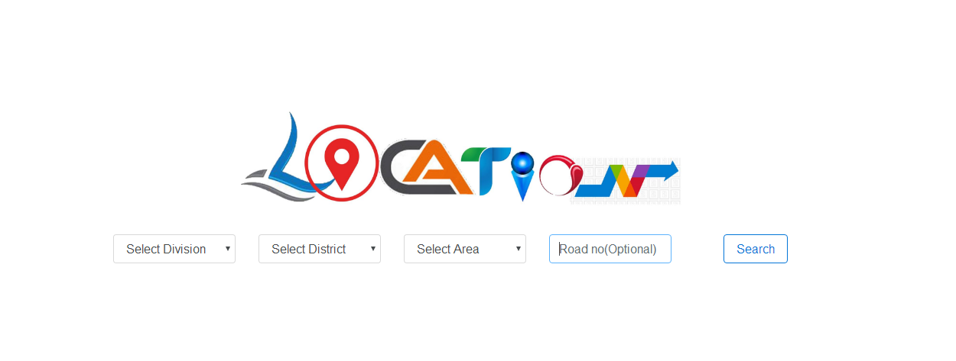

Step 2: After putting the location name on the search option,user will get a menu to choose.

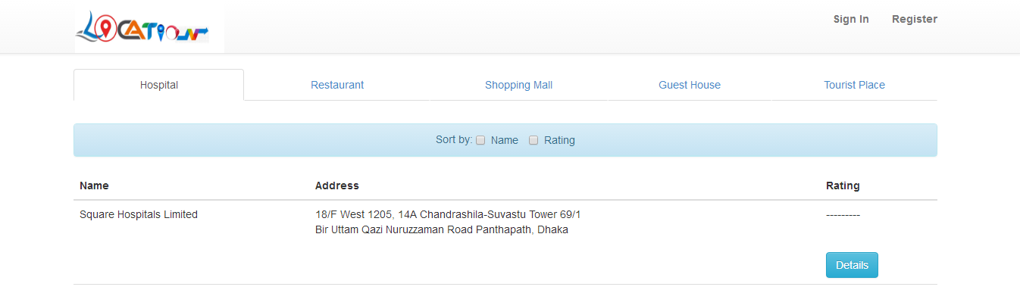

Step 3:Imagine that user choose hospital and location is Sankar. Then he’ll get the list of hospitals situated in Sankar with a short address & rating. He’ll chose a hospital that he need.

Step 4.a: After choosing a hospital, he’ll get some basic details of that hospital. He’ll get the image, division (like Eye,Cancer, Neurosurgery,Child etc.), outdoor. After selecting one division, he’ll get the doctors name & time. For more details, he’ll get the website & phone number of that hospital. This is about hospital.

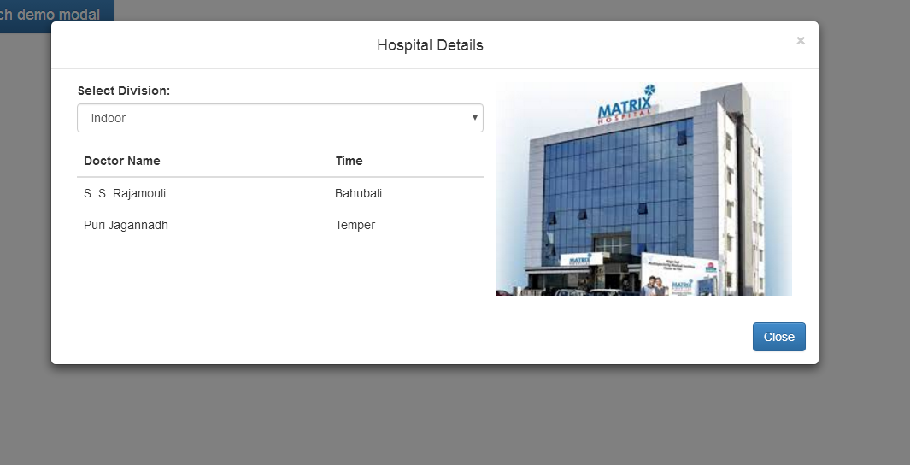

B): Suppose, user chooses shopping complex of Sankar. Then he’ll get the list of shopping malls situated in Sankar with a short address & rating. He’ll chose a shopping mall.

After choosing a shopping mall, he’ll get some basic details of that shopping mall. He’ll get the image, categories of necessary things and which floor they are in. For more details, there will also be a website and phone number of that shopping mall.

C) Suppose, user chooses hotel/guest house of Sankar. Then he’ll get the list of hotels/guest houses situated in Sankar with a short address & rating. He’ll chose a hotel or guest house.

After choosing a hotel, he’ll get some basic details of that hotel. He’ll get the image, packages, facilities, cost, special offers. For more details, he’ll get the website and phone number there.

D) In same process, user can choose a restaurant from the list. He’ll get the image, menu, prices, offers. For more details, there is also the website and phone number of that restaurant.

In same way, user can choose a tourist place from the list. He’ll get the image, category, day time, off day. For more details, there is also the website and phone number of that place.

This is about our project in short. Our plan is to add in which way user will go there. There will be a option to provide us a feedback to improve our website. That’s all about our goal of this project till now.

Thank You, Ma’m.